Lab 1:

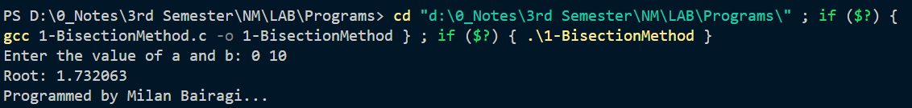

Lab 2:

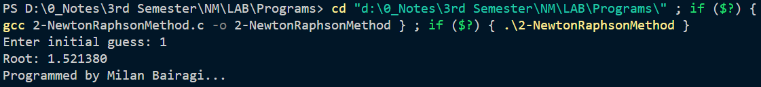

Lab 3:

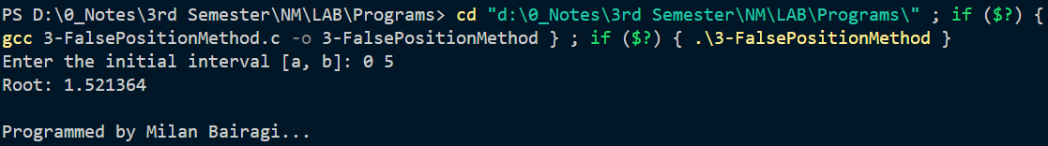

Lab 4:

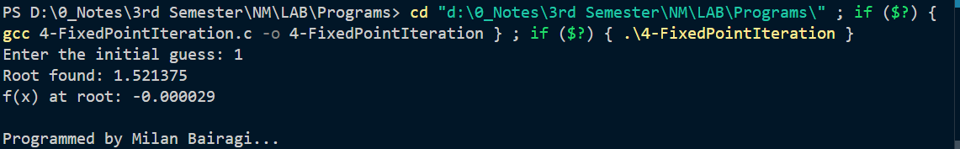

Lab 5:

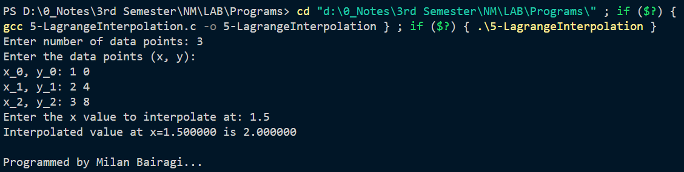

Lab 6:

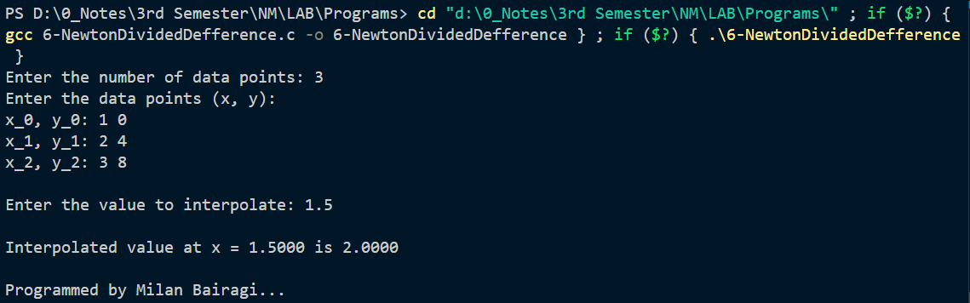

Lab 7:

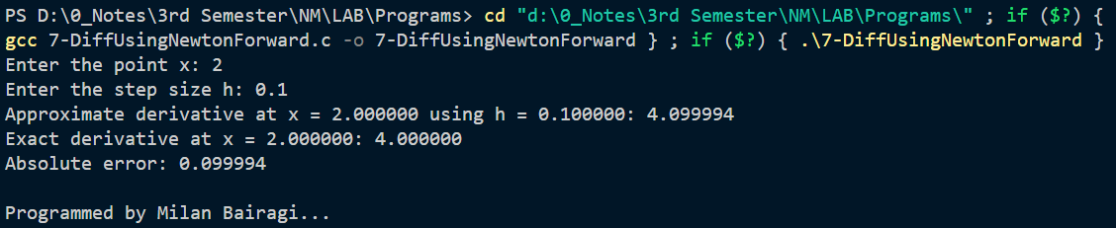

Lab 8:

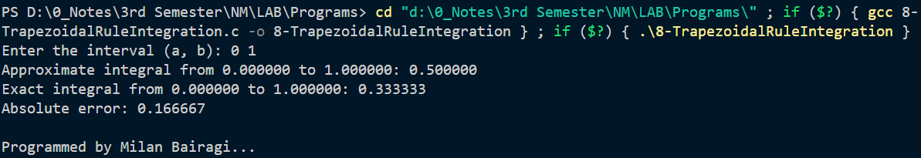

Lab 9:

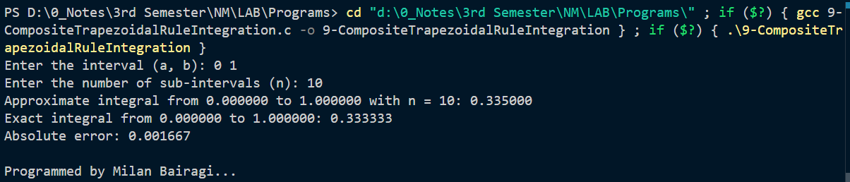

Lab 10:

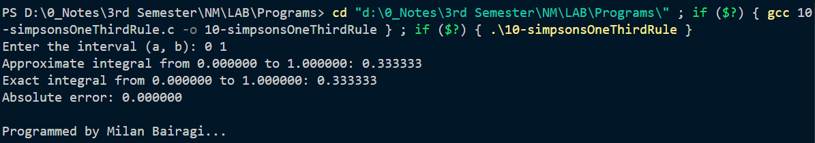

Lab 11:

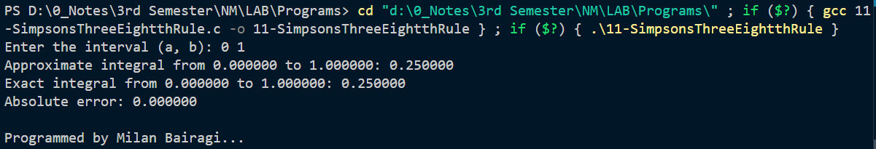

Lab 12:

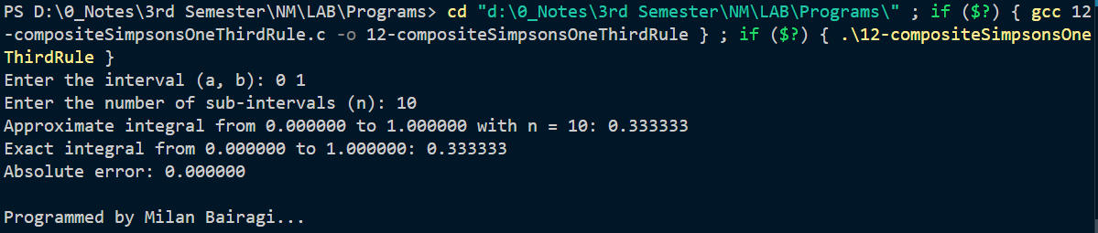

Lab 13:

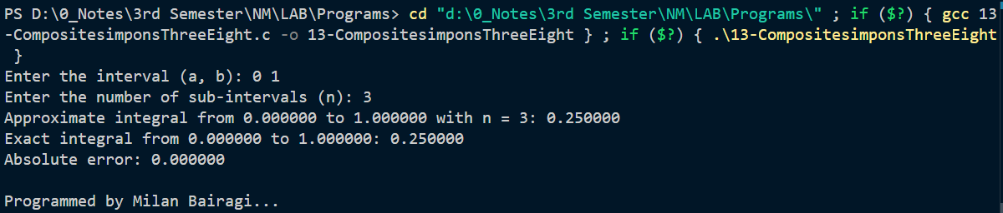

Lab 14:

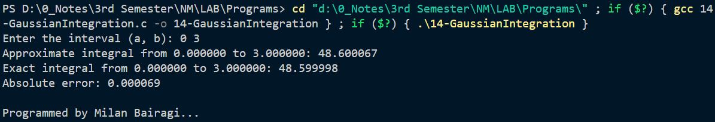

Lab 15:

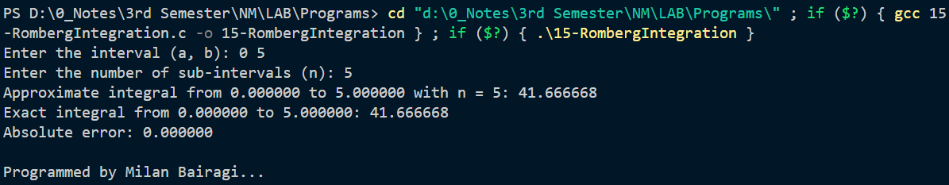

Lab 16:

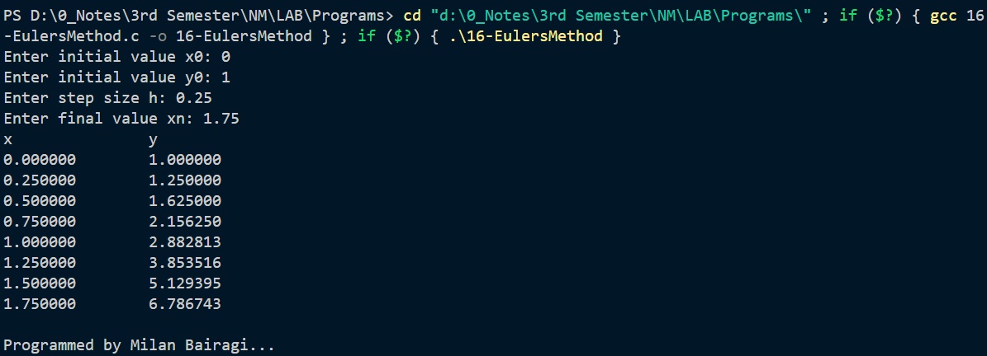

Lab 17:

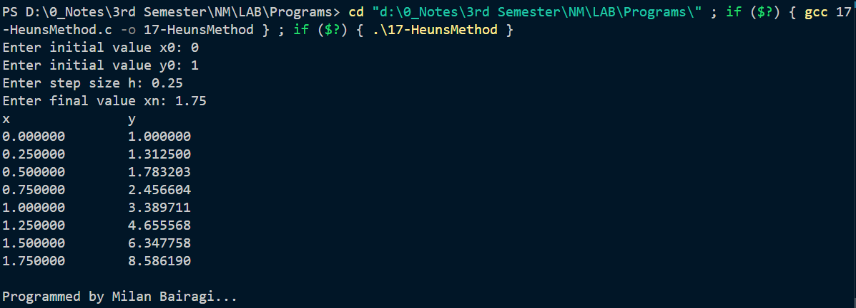Lab 18:

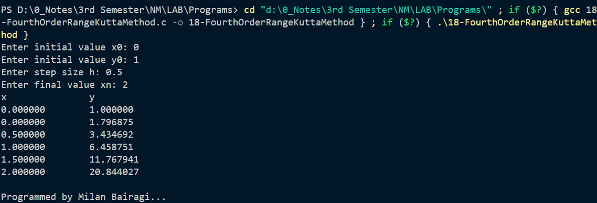

Lab 19:

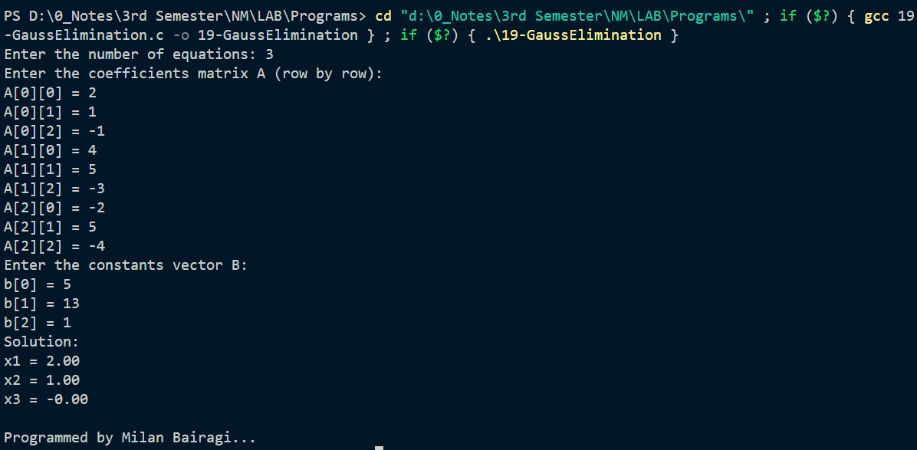

Lab 20:

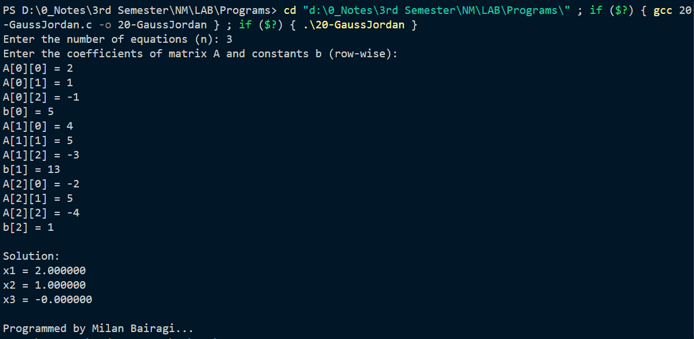

Lab 21:

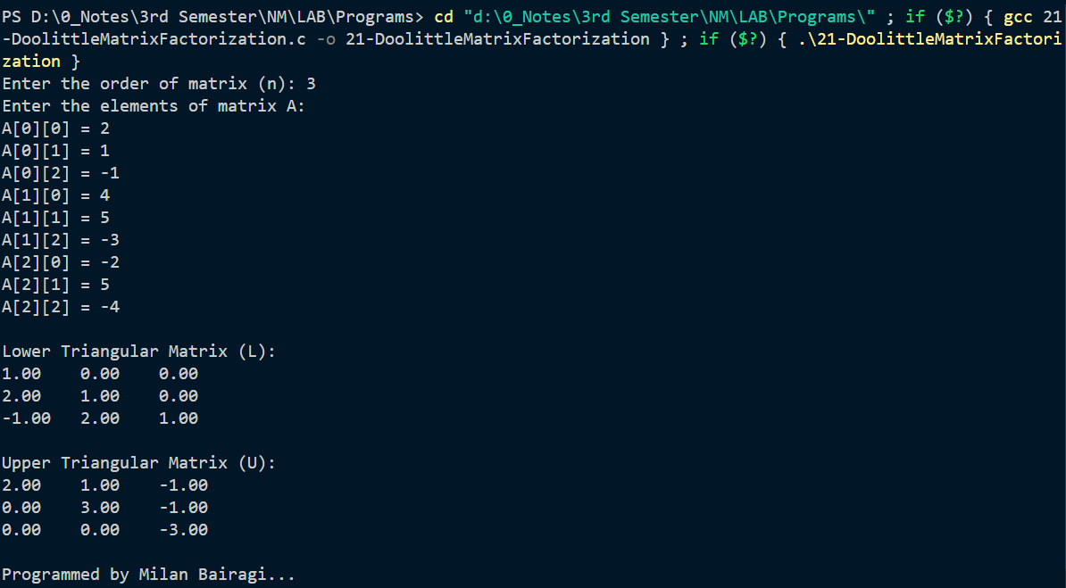

Lab 22:

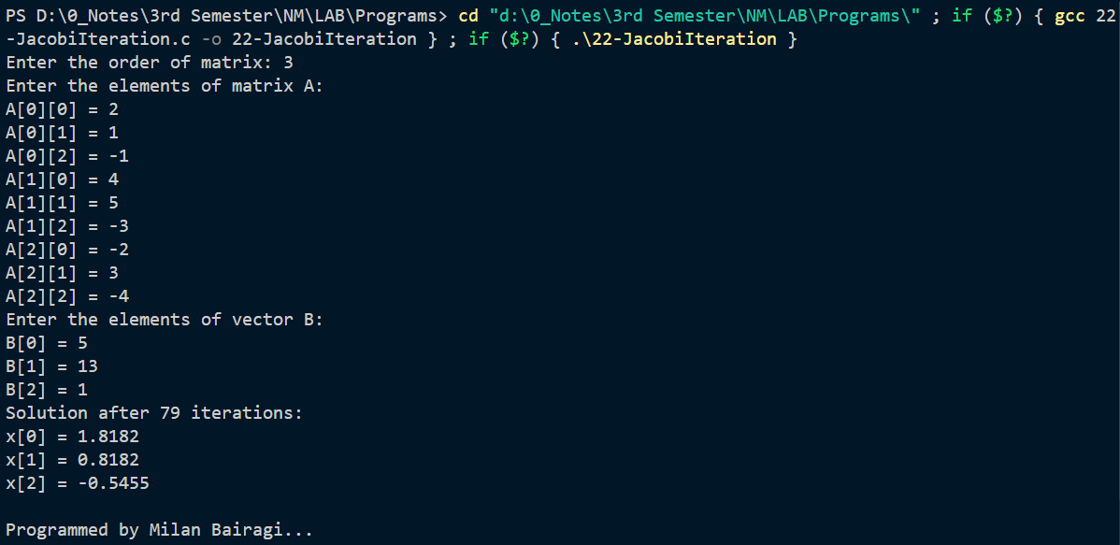

Lab 23:

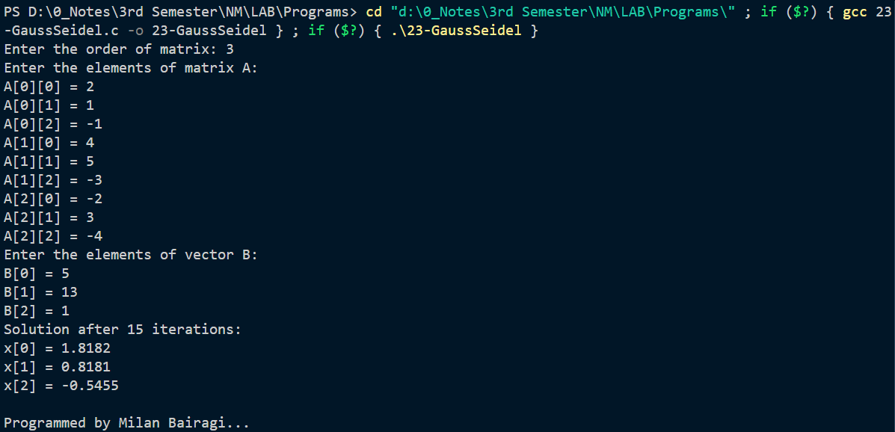

Lab 24:

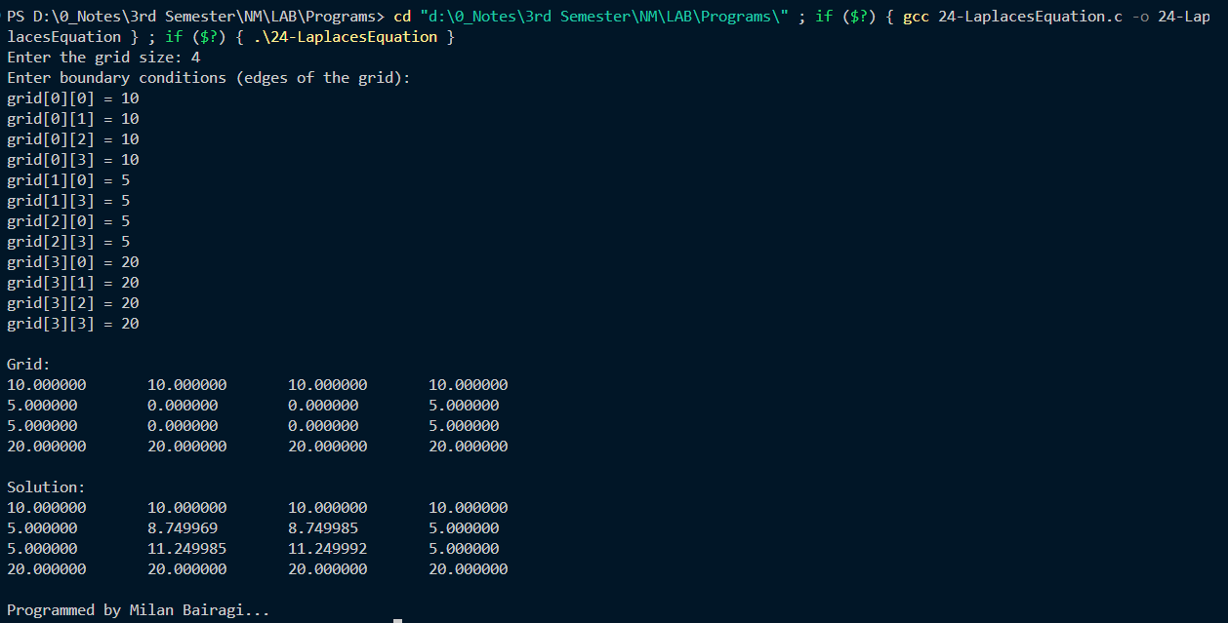

Lab 25:

